Complexity Theory – the Stacey matrix

Ralph Stacey has developed a model for approaching complex situations in management settings, which I believe you may find useful on the VTS

It can help to guide you by offering an additional method to select the appropriate management actions in a complex adaptive system (CAS) based on two axes:
- Vertical axis = the degree of certainty and
- Horizontal axis = level of agreement on the issue in question.

Possible applications
- Choosing management or leadership approaches for a specific issue or decision.
- Making sense of an array of decisions (or agenda for a group).
- Communicating with others why a particular approach is appropriate.
- Promote creativity: When innovations and creative alternatives are needed, this matrix can be used to deliberately increase the uncertainty and disagreement and so nudge the system to the edge of chaos and potential creativity.

Definitions

Close to Certainty
Issues or decisions are close to certainty when cause and effect linkages can be determined. This is usually the case when a very similar issue or decision has been made in the past. One can then extrapolate from past experience to predict the outcome of an action with a high degree of certainty.

Far from Certainty
At the other end of the certainty continuum are decisions that are far from certainty. These situations are often unique or at least new to the decision makers. The cause and effect linkages are not clear. Extrapolating from past experience is not a good method to predict outcomes in this area far from certainty.

Agreement
The vertical axis measures the level of agreement about an issue or decision within the group, team or organization. As you would expect, the management or leadership function varies depending on the level of agreement surrounding an issue.

The Edge of Chaos (The Zone of Complexity)
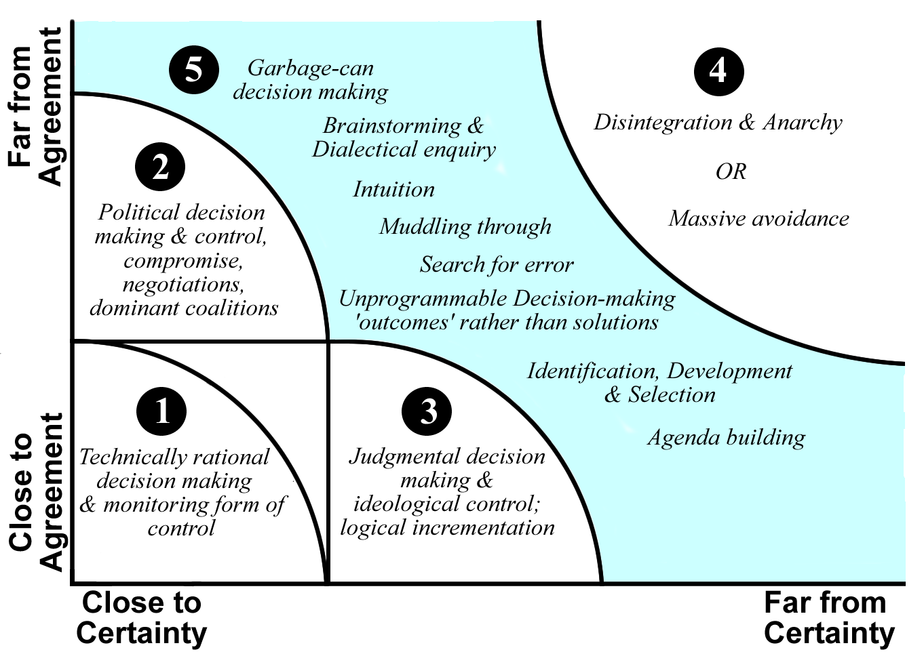

There is a large area on this diagram which lies between the anarchy/chaos region (4) and regions of the traditional management approaches (1, 2 & 3). Stacey calls this large center region the zone of complexity (5) - others call it the edge of chaos. In the zone of complexity the traditional management approaches are not very effective but it is the zone of high creativity, innovation, and breaking with the past to create new modes of operating.

- Technical Rational decision-making: Much of the management literature and theory addresses the region on the matrix which is close to certainty and close to agreement. In this region, we use techniques which gather data from the past and use them to predict the future. We plan specific paths of action to achieve outcomes and monitor the actual behavior by comparing it against these plans. This is sound management practice for issues and decisions that fall in this area. The goal is to repeat what works to improve efficiency and effectiveness.

- Political decision-making: Some issues have a great deal of certainty about how outcomes are created but high levels of disagreement about which outcomes are desirable. Neither plans nor shared mission are likely to work in this context. Instead, politics become more important. Coalition building, negotiation, and compromise are used to create the organization's agenda and direction.

- Judgemental decision-making.:Some issues have a high level of agreement but not much certainty as to the cause and effect linkages to create the desired outcomes. In these cases, monitoring against a preset plan will not work. A strong sense of shared mission or vision may substitute for a plan in these cases. Comparisons are made not against plans but against the mission and vision for the organization. In this region, the goal is to head towards an agreed upon future state even though the specific paths cannot be predetermined.

- Anarchy/Chaos: Situations where there are very high levels of uncertainty and disagreement, often result in a breakdown or anarchy. The traditional methods of planning, visioning, and negotiation are insufficient in these contexts. One strategy to deal with such contexts is avoidance of the issues that are highly uncertain and where there is little disagreement. While this may be a protective strategy in the short run, it is disastrous in the long run. This is a region that organizations should avoid as much as possible.

- Complexity zone: There is a large area on this diagram, which lies between the anarchy region and regions of the traditional management approaches. Stacey calls this large center region the zone of complexity - others call it the edge of chaos. In the zone of complexity the traditional management approaches are not very effective but it is the zone of high creativity, innovation, and breaks with the past to create new modes of operating. In management much time is spent teaching how to manage in areas (1), (2) and (3). In these regions, models are presented which extrapolate from past experience and are thereby used to forecast the future. This is the hallmark of good science in the traditional mode. Models in area (4) may seem 'soft' by lacking of prediction. Managers and leaders of organizations need to have a diversity of approaches to deal with the diversity of contexts. Stacey's matrix honors what we already have learned but also urges us to move with more confidence into some of the areas which we understand intuitively but are hesitant to apply because they do not appear as 'solid.'

Acknowledgement & thanks:
Personal communication with Ralph Stacey & permission to use Matrix

Reference:
Brenda Zimmerman, Schulich School of Business, York University, Edgeware Aides, Toronto, Canada

